**SAP – Reports**

There are many reports available in SAP. As you must be knowing that there are various sub modules such as GL, AP, AR etc in each of these sub modules there is a folder calls "Information System" in this folder you can search for various reports that you can show to your client.

Execute Transaction Code SAP1 for Report Menu, list of report transcation codes with respective modules are available.

This tutorial will give you an overview of important reports which are used frequently in SAP FI. Following is list of important reports

1. GL Chart Of Accounts List
2. GL Account List
3. GL Account Balances
4. GL Account Totals And Balances
5. AR Customer Master Data List
6. AR Customer Balances
7. AR Customer Line Items
8. AR Customer Open Item Analysis Drilldown Report
9. AR Customer Payment History
10. AP Vendor Master Data List
11. AP Vendor Balances
12. AP Vendor Line Items
13. AP Vendor Open Item Analysis

We will now discuss them one by one.

**GL Chart Of Accounts List**

Enter Transaction Code S_ALR_87012326 in the SAP Command Field

[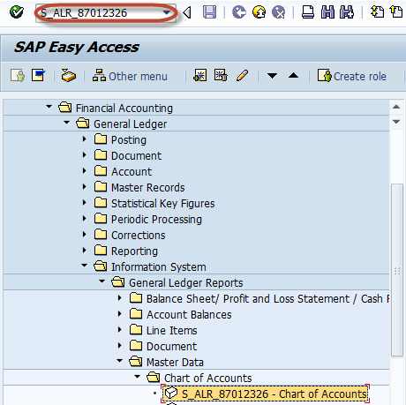](http://www.guru99.com/images/sap/2012/05/CoaBal011.png)

In the next screen , Enter Chart of Account Key

[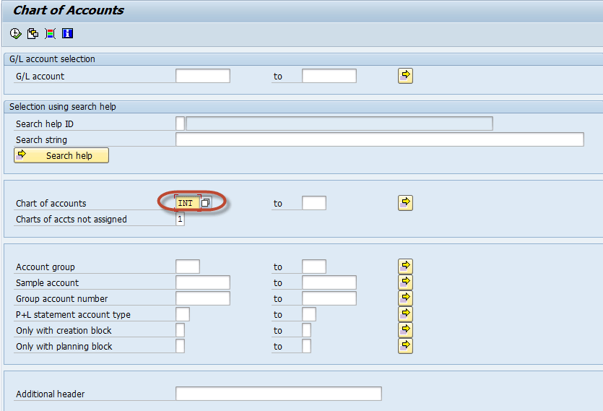](http://www.guru99.com/images/sap/2012/05/CoaBal021.png)

Press F8 (Execute) The GL Chart of Accounts List is Generated for COA key mentioned in the last screen

[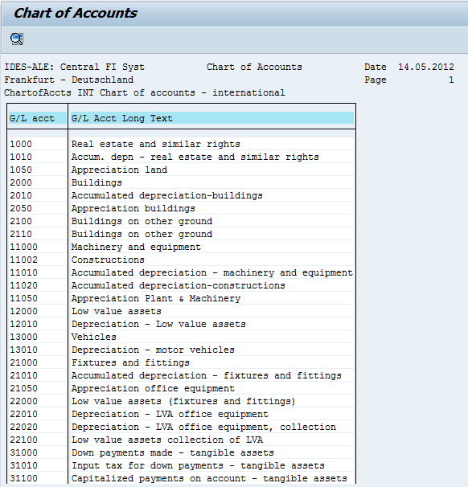](http://www.guru99.com/images/sap/2012/05/CoaBal032.png)

**GL Account List**

Enter Transaction Code S_ALR_87012328  in SAP Command Field

[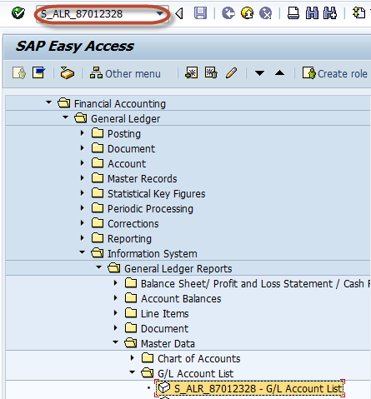](http://www.guru99.com/images/sap/2012/05/AccLst011.png)

  In the next screen, Enter Selection Parameters like Company Code / Chart of Accounts / GL Account for Filtering. Entering these parameters is optional

[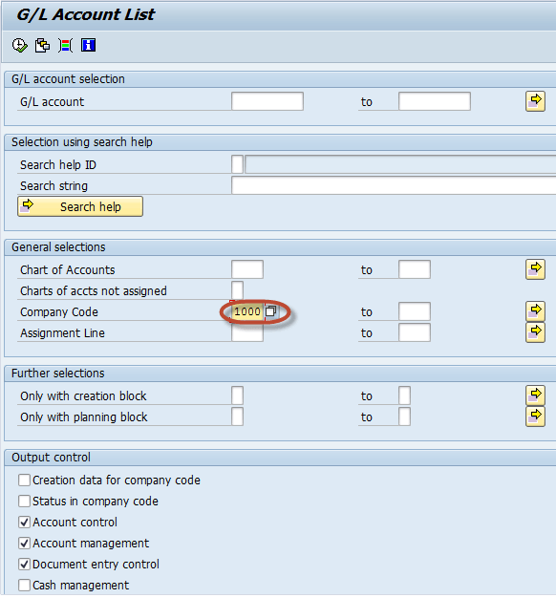](http://www.guru99.com/images/sap/2012/05/AccLst021.png)

  Press F8 (Execute) The GL Account List is generated as per the filtering selections from the previous screen . Otherwise complete list is generated for all company code and chart of accounts

[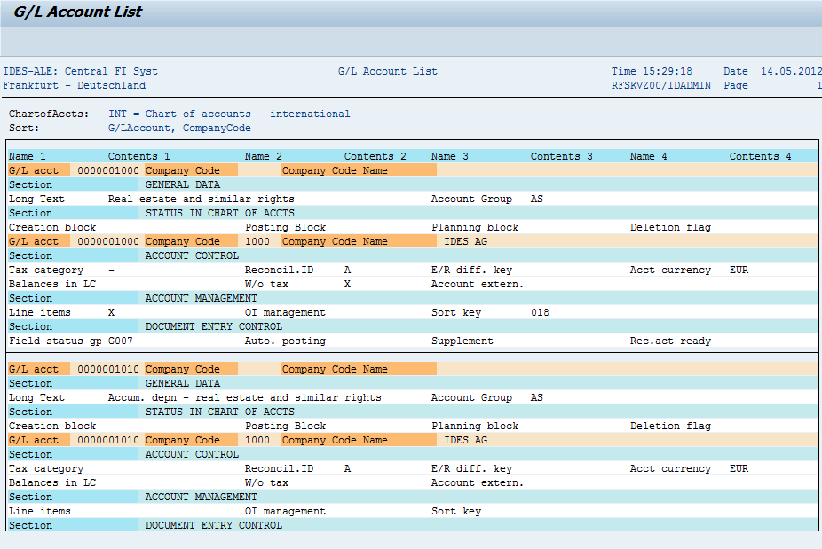](http://www.guru99.com/images/sap/2012/05/AccLst031.png)

**GL Account Balances**

Enter Transaction Code S_ALR _87012277  in the SAP Command Field

[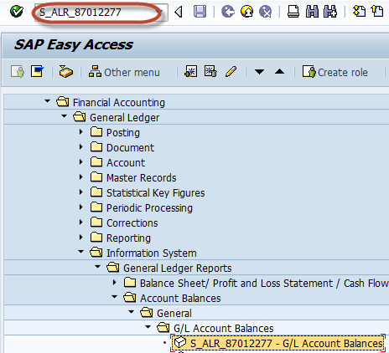](http://www.guru99.com/images/sap/2012/05/AccBal011.png)

In the next screen, Enter Selection Parameters for Filtering the Report such as Company code / GL Account

[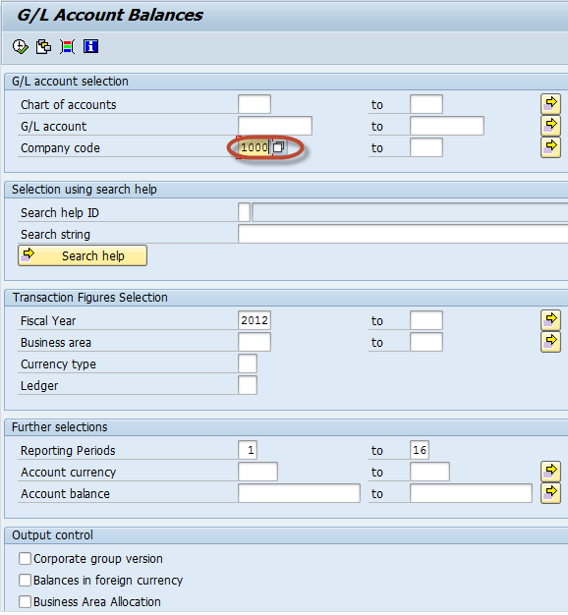](http://www.guru99.com/images/sap/2012/05/AccBal021.png)

  Press F8 (Execute) In the next screen, GL Account Balance List is generated as per the parameters entered in the previous screen

[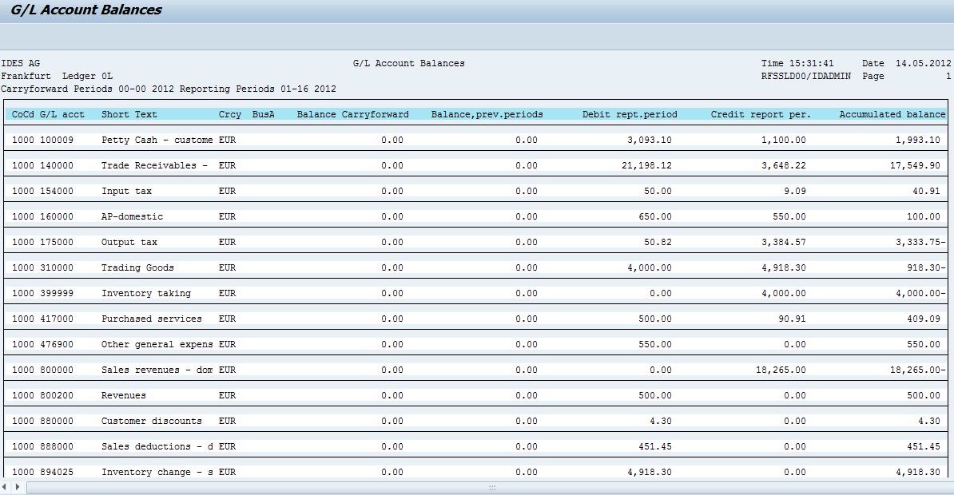](http://www.guru99.com/images/sap/2012/05/AccBal032.png)

**GL Account  Totals and Balances**

Enter Transaction code S_ALR_ 87012301 in the Sap Command Field

[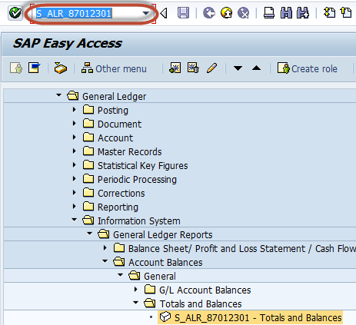](http://www.guru99.com/images/sap/2012/05/GLtotnBal01.png)

In the next screen , Enter Selection Criteria like Company Code/ COA / Gl Accounts for the filtering the Report

[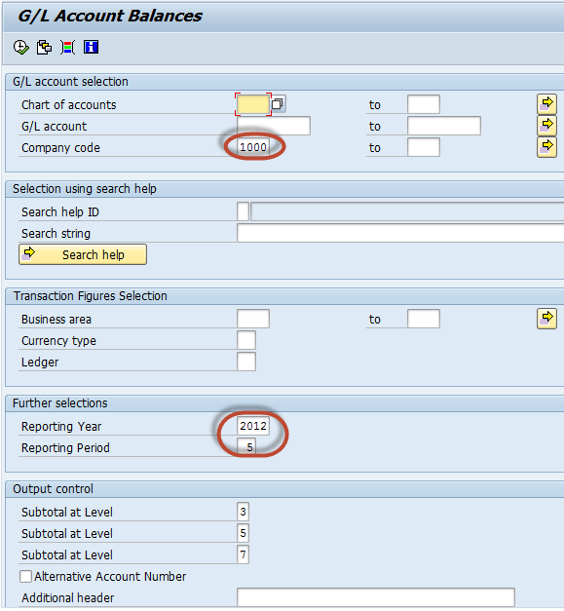](http://www.guru99.com/images/sap/2012/05/GLtotnBal02.png)

  In the next screen , GL Account Total and Balance report is generated as per the parameters selected in the previous screen

[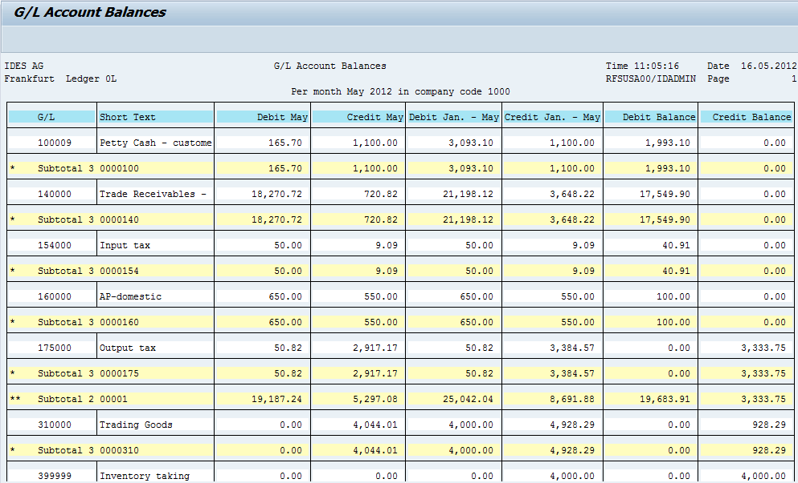](http://www.guru99.com/images/sap/2012/05/GLtotnBal03.png)

**AR Customer Master Data List**

  Enter Transaction S_ALR_87012179  in SAP Command Field

[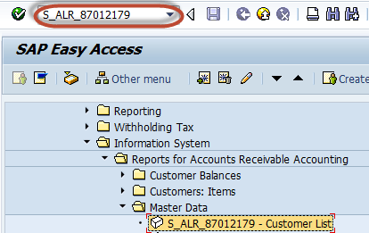](http://www.guru99.com/images/sap/2012/05/Cuslist01.png)

  In the next screen , Enter Selection Criteria for the filtering the Report

[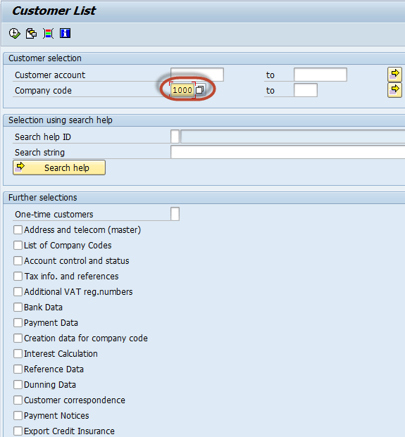](http://www.guru99.com/images/sap/2012/05/Cuslist02.png)

  In the next screen , AR Customer Master Data List is  generated as per the parameters selected in the previous screen

[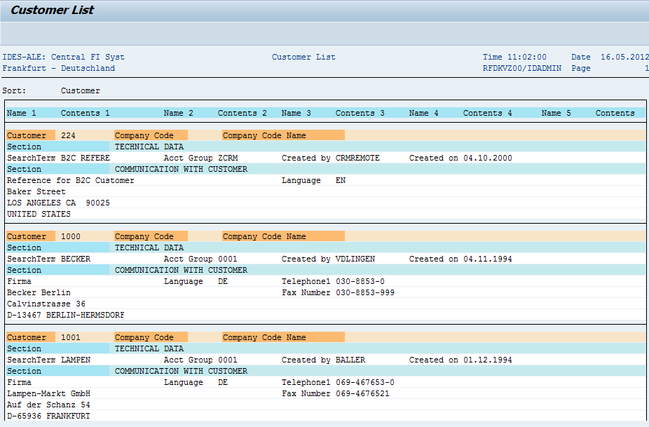](http://www.guru99.com/images/sap/2012/05/Cuslist03.png)

**AR Customer Balances**

Enter Transaction Code S_ALR_87012172 in the SAP Command Field

[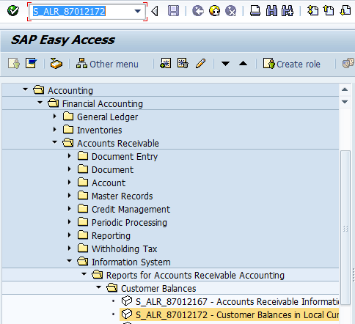](http://www.guru99.com/images/sap/2012/05/CusBal01.png)

In the next screen, Enter Selection Criteria for the filtering the Report

[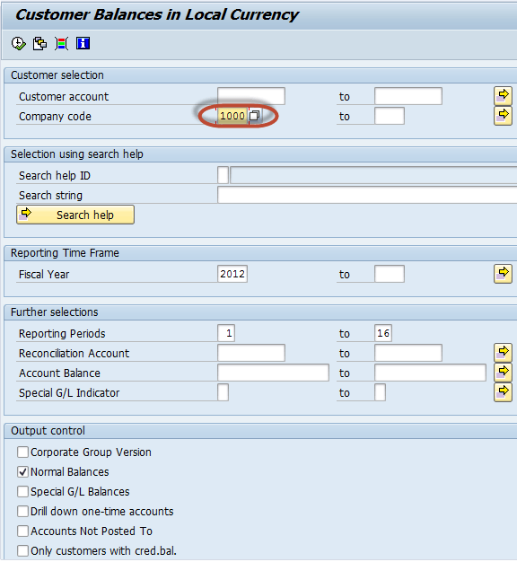](http://www.guru99.com/images/sap/2012/05/CusBal021.png)

  In the next screen , AR Customer Balance Report  is  generated as per the parameters selected in the previous screen

[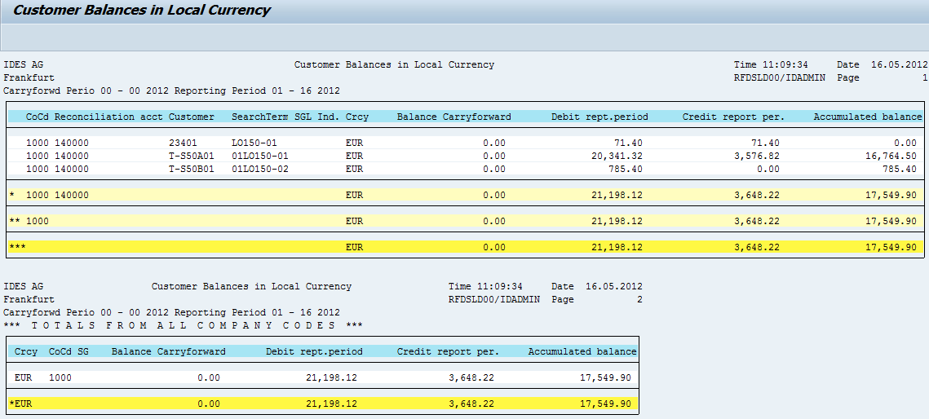](http://www.guru99.com/images/sap/2012/05/CusBal03.png)

**AR Customer Line Items**

  Enter Transaction Code S_ALR_87012197 in the SAP Command Field

[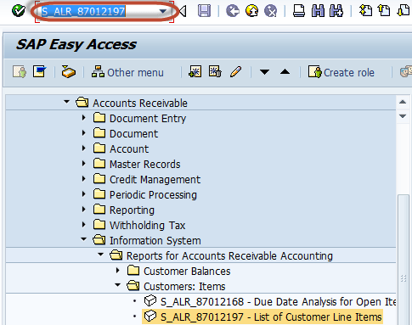](http://www.guru99.com/images/sap/2012/05/CusLinItem01.png)

In the next screen , Enter Selection Criteria for the filtering the Report

[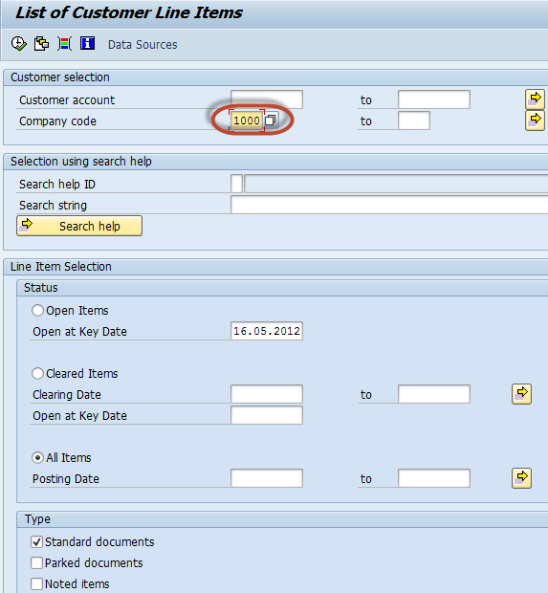](http://www.guru99.com/images/sap/2012/05/CusLinItem02.png)

In the next screen , AR Customer Line Item Report  is  generated as per the parameters selected in the previous screen

[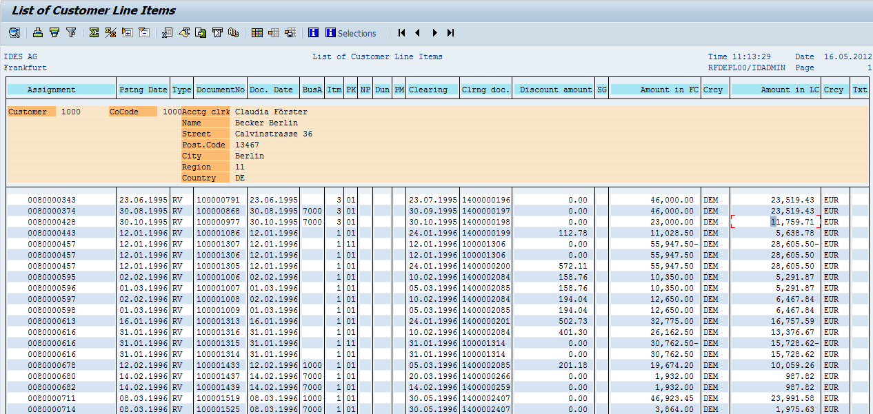](http://www.guru99.com/images/sap/2012/05/CusLinItem03.png)

**AR Customer Open Items**

  Enter Transaction Code S_ALR_87012174  in the SAP Command Field

[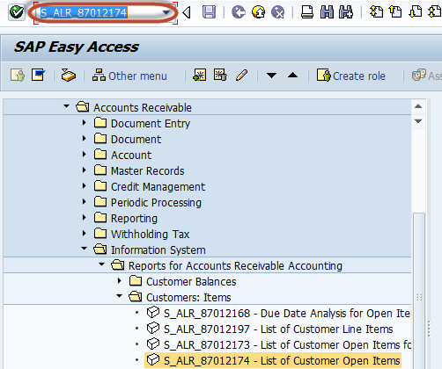](http://www.guru99.com/images/sap/2012/05/CustOpen011.png)

In the next screen , Enter Selection Criteria for the filtering the Report

[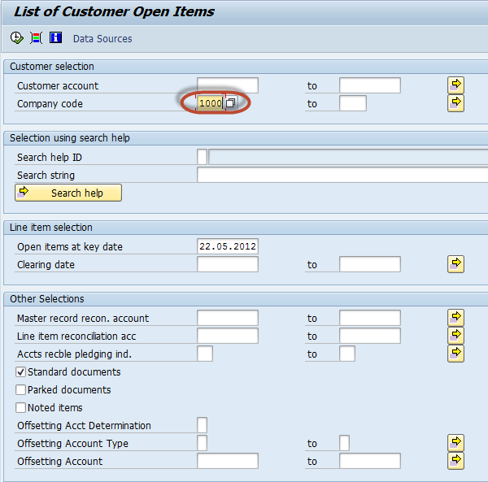](http://www.guru99.com/images/sap/2012/05/CustOpen021.png)

  In the next screen , AR Customer Open Item Report  is  generated as per the parameters selected in the previous screen

[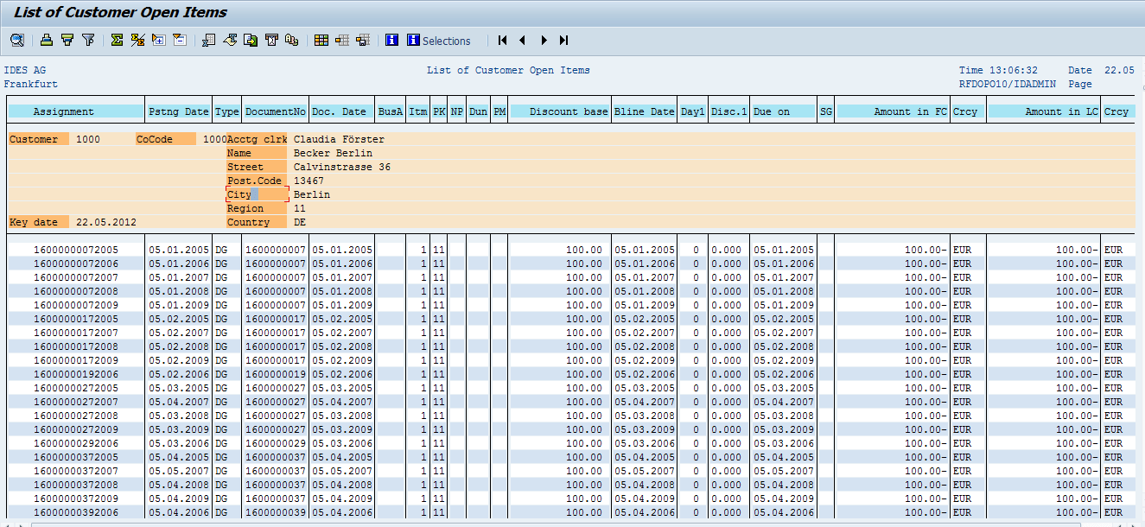](http://www.guru99.com/images/sap/2012/05/CustOpen03.png)

**AR Customer Payment History**

Enter Transaction Code S_ALR_87012177 in SAP Command Field

[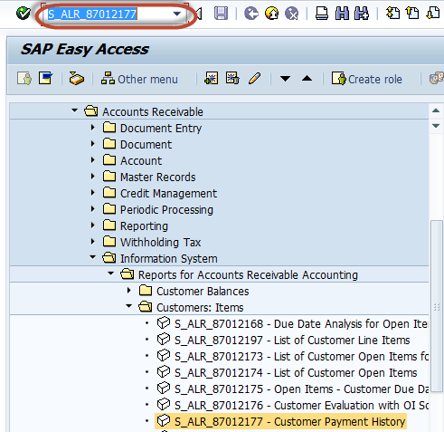](http://www.guru99.com/images/sap/2012/05/CustPayH01.png)

In the next screen , Enter Selection Criteria for the filtering the Report

[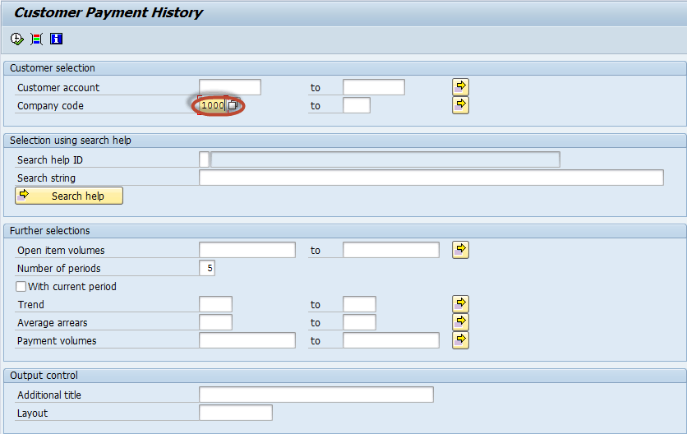](http://www.guru99.com/images/sap/2012/05/CustPayH02.png)

In the next screen , AR Customer Payment History Report  is  generated as per the parameters selected in the previous screen

[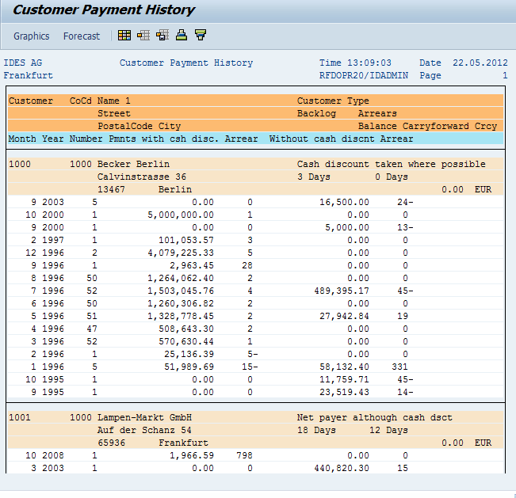](http://www.guru99.com/images/sap/2012/05/CustPayH03.png)

**AP Vendor Master Data List**

Enter Transaction Code S_ALR_87012086  in SAP Command Field

[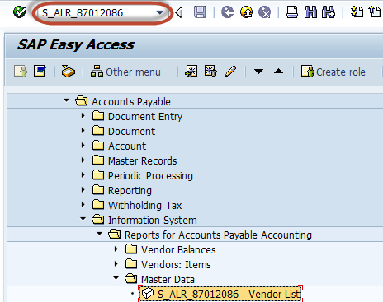](http://www.guru99.com/images/sap/2012/05/VendList01.png)

In the next screen , Enter Selection Criteria for the filtering the Report

[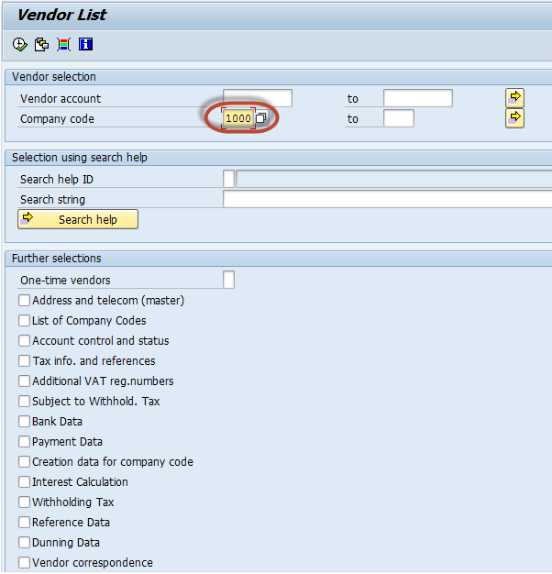](http://www.guru99.com/images/sap/2012/05/VendList02.png)

In the next screen , AP Vendor Master Data List Report  is  generated as per the parameters selected in the previous screen

[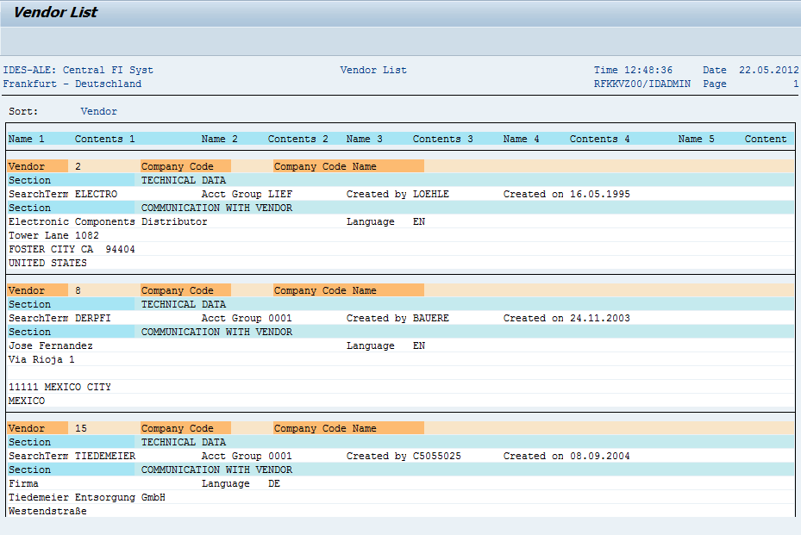](http://www.guru99.com/images/sap/2012/05/VendList03.png)

**AP Vendor Balances**

Enter Transaction Code S_ALR_87012082 in SAP Command Field

[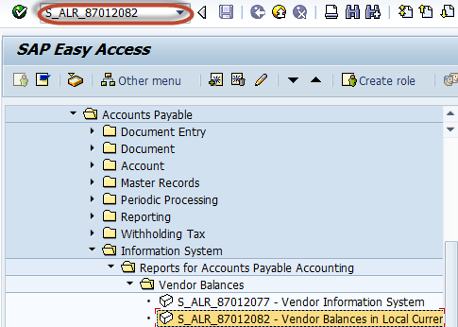](http://www.guru99.com/images/sap/2012/05/VendBal01.png)

In the next screen , Enter Selection Criteria for the filtering the Report

[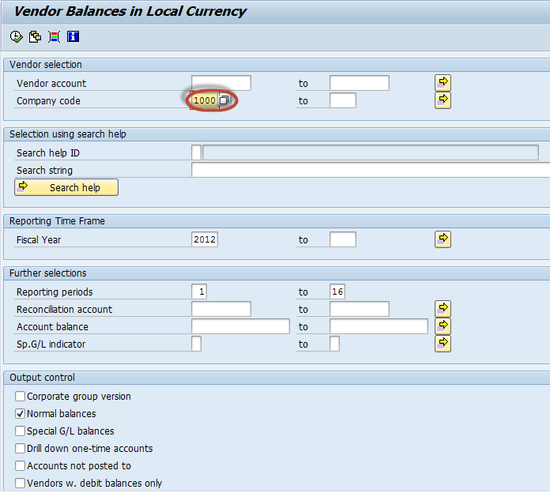](http://www.guru99.com/images/sap/2012/05/VendBal02.png)

In the next screen , AP Vendor Balances Report  is  generated as per the parameters selected in the previous screen

**[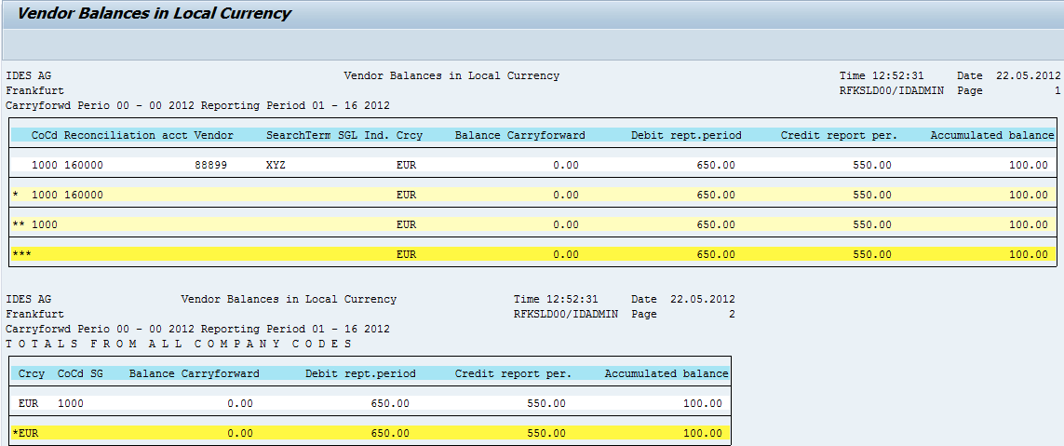](http://www.guru99.com/images/sap/2012/05/VendBal03.png)**

**AP Vendor Line Items**

Enter Transaction Code S_ALR_87012103 in SAP Command Field

[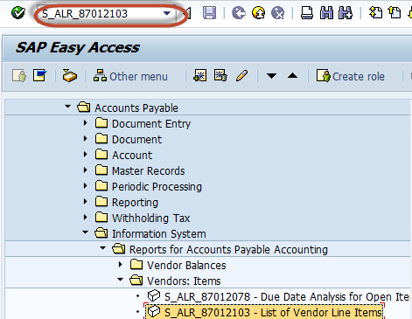](http://www.guru99.com/images/sap/2012/05/VendLine01.png)

In the next screen , Enter Selection Criteria like Company code / Vendor Accounts for the filtering the Report

[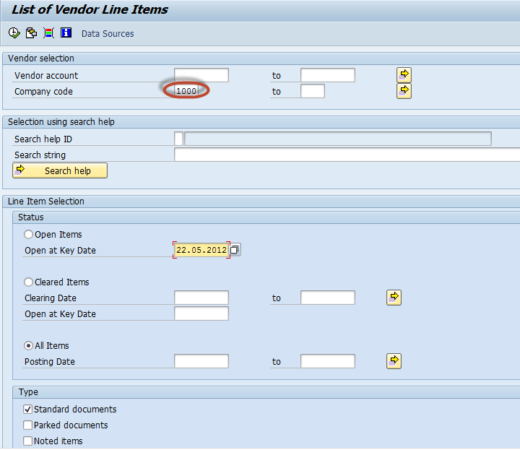](http://www.guru99.com/images/sap/2012/05/VendLine02.png)

In the next screen , AP Vendor Line Items  List Report  is  generated as per the parameters selected in the previous screen

**[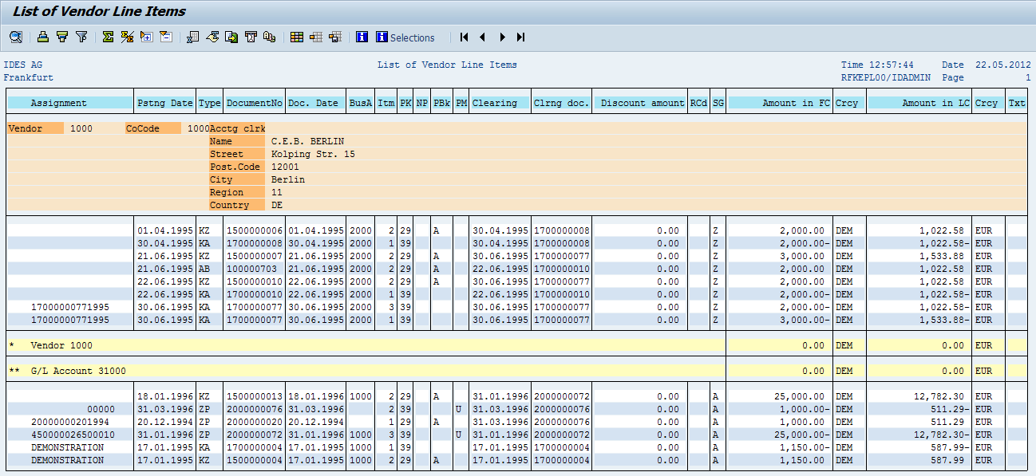](http://www.guru99.com/images/sap/2012/05/VendLine03.png)**

**AP Vendor Open Item Analysis**

Enter Transaction Code S_ALR_87012083  in SAP Command Field

[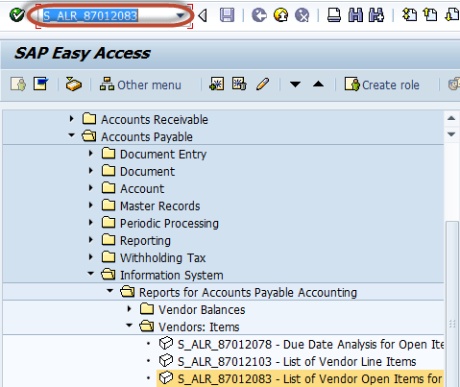](http://www.guru99.com/images/sap/2012/05/VendPay012.png)

In the next screen , Enter Selection Criteria for the filtering the Report

[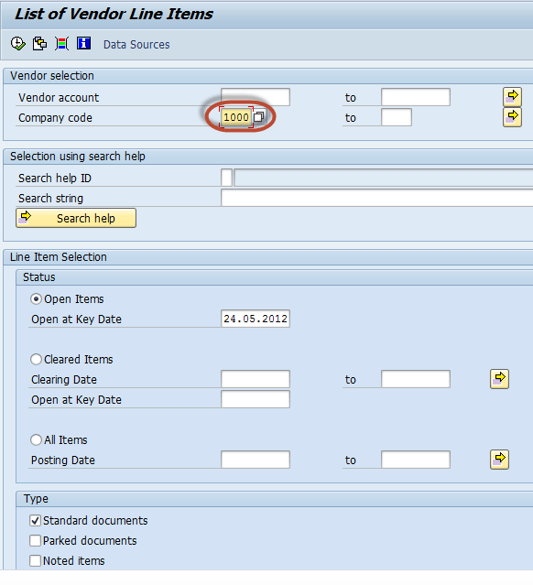](http://www.guru99.com/images/sap/2012/05/VendPay021.png)

In the next screen , AP Vendor Open Item Analysis Report  is  generated as per the parameters selected in the previous screen

[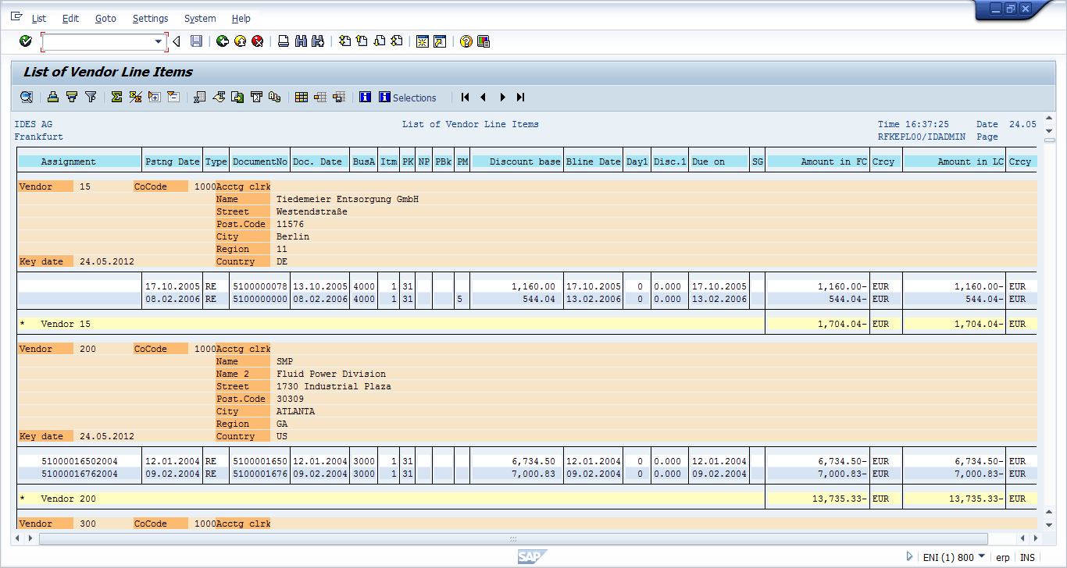](http://www.guru99.com/images/sap/2012/05/VendPay031.png)

|  |  |  |
| --- | --- | --- |
| Controlling |  |  |
|  | S_ALR_87013611 | Cost Centers: Actual/Plan/Variance |
|  | S_ALR_87013612 | Range: Cost Centers |
|  | S_ALR_87013613 | Range: Cost Elements |
|  | S_ALR_87013614 | Cost Centers: Current Period/Cumulative |
|  | S_ALR_87013616 | Cost Centers: Breakdown by Business Transaction |
|  | S_ALR_87013617 | Range: Activity Types |
|  | S_ALR_87013618 | Range: Statistical Key Figures |
|  | S_ALR_87013619 | Range: Assigned Orders/WBS Elements |
|  | S_ALR_87013620 | Cost Centers: Actual/Plan/Commitments |
|  | S_ALR_87013621 | Range: Actual/Plan/Commitments |
|  | S_ALR_87013623 | Cost Centers: Quarterly Comparison |
|  | S_ALR_87013624 | Cost Centers: Fiscal Year Comparison |
|  | S_ALR_87013625 | Cost Centers: Actual/Target/Variance |
|  | S_ALR_87013626 | Range: Cost Elements |
|  | KSBL | Cost Centers: Planning Overview |
|  | S_ALR_87013630 | Activity Types: Plan Receivers |
|  | KSBT | Cost Centers: Activity Prices |
|  | KSB1 | Cost Centers: Actual Line Items |
|  | KSB2 | Cost Centers: Commitment Line Items |
|  | KSBP | Cost Centers: Plan Line Items |
|  | KSB5 | CO Documents: Actual Costs |
|  | KABP | CO Plan Documents |
|  | KS13 | Cost Centers: Master Data Report |
|  | KA23 | Cost Elements: Master Data Report |
|  | KL13 | Activity Types: Master Data Report |
|  | KK04 | Statistical Key Figures: Master Data Report |
|  | S_ALR_87013631 | Cost Centers: Rolling Year |
|  | S_ALR_87013632 | Cost Centers: Average Costs |
|  | S_ALR_87013633 | Cost Centers: Actual/Plan/Variance/Previous year |
|  | S_ALR_87013635 | Area: Actual/Plan 2 Currencies |
|  | S_ALR_87013636 | Cost Centers: Object Comparison |
|  | S_ALR_87013637 | Area: Internal Business Volume |
|  | S_ALR_87013638 | Cost Centers: Current/Cumulative/Fiscal Year |
|  | S_ALR_87013639 | Cost Centers: Actual/Target from Summarization |
|  | S_ALR_87013640 | Cost Centers: Period Breakdown Actual/Plan |
|  | S_ALR_87013641 | Cost Centers: Period Breakdown Actual/Target |
|  | S_ALR_87013642 | Cost Centers: Breakdown Resources |
|  | S_ALR_87013643 | Range: Orders |
|  | S_ALR_87013645 | Statistical Key Figures: Period Breakdown |
|  | S_ALR_87013646 | Activity Types: Period Breakdown |
|  | S_ALR_87013648 | Range: Actual/Budget/Commitments |
|  | S_ALR_87012993 | Orders: Actual/Plan/Variance |
|  | S_ALR_87012994 | Orders: Current Period/Cumulative |
|  | S_ALR_87012995 | List: Orders |
|  | S_ALR_87012996 | List: Orders by Cost Element |
|  | S_ALR_87012997 | List: Cost Elements by Order |
|  | S_ALR_87012998 | Orders: Breakdown by Partner |
|  | S_ALR_87012999 | Orders: Actual/Plan/Commitments |
|  | S_ALR_87013000 | List: Actual/Plan/Commitments |
|  | S_ALR_87013001 | Orders: Actual Yearly Comparison |
|  | S_ALR_87013002 | Orders: Actual quarterly comparison |
|  | S_ALR_87013003 | Orders: Actual Period Comparison |
|  | KABL | Order: Planning Overview |
|  | S_ALR_87013004 | Order: Plan Yearly Comparison |
|  | S_ALR_87013005 | Orders: Plan Quarterly Comparison |
|  | S_ALR_87013006 | Orders: Plan Period Comparison |
|  | KOB1 | Orders: Actual Line Items |
|  | KOB2 | Orders: Commitment Line Items |
|  | KOBP | Orders: Plan Line Items |
|  | KOB4 | Orders: Budget Line Items |
|  | KSB5 | CO Documents: Actual Costs |
|  | KABP | CO Plan Documents |
|  | KO2B | Display Budget Document |
|  | KOK5 | Internal Orders |
|  | KOSRLIST_OR | Settlement Rules |
|  | KA23 | Cost Elements |
|  | KK04 | Statistical Key Figures |
|  | S_ALR_87013010 | Orders: Breakdown by Period |
|  | S_ALR_87013011 | Orders: Actual/Plan/Price Variance |
|  | S_ALR_87013012 | Orders: Actual/Plan/Consumption |
|  | S_ALR_87013013 | Orders: Actual in Transaction/Object/Group Currencies |
|  | S_ALR_87013014 | List: Cost Elements (True Postings) |
|  | S_ALR_87013015 | List: Actual Debit/Credit |
|  | S_ALR_87013016 | List: Plan Debit/Credit |
|  | S_ALR_87013017 | List: Actual/Plan/Variance, Cumulative |
|  | S_ALR_87013018 | List: Total Plan/Actual/Commitments |
|  | S_ALR_87013019 | List: Budget/Actual/Commitments |
|  | KOC4 | Cost Analysis |
|  |  |  |
| General Ledger |  |  |
|  | S_PL0_86000028 | Fin. Statement: Actual/Actual Comparison |
|  | S_ALR_87012284 | Financial Statements |
|  | S_PL0_86000029 | Fin. Statement: Plan/Actual Comparison |
|  | S_ALR_87012271 | Cash Flow (Direct Method) |
|  | S_ALR_87012272 | Cash Flow (Indirect Method) Variant 1 |
|  | S_ALR_87012273 | Cash Flow (Indirect Method) Variant 2 |
|  | FSIB | Background Processing |
|  | S_ALR_87012277 | G/L Account Balances |
|  | S_PL0_86000030 | G/L Account Balances (New) |
|  | S_PL0_86000031 | Transaction Figures: Account Balance |
|  | S_ALR_87012301 | Totals and Balances |
|  | S_PL0_86000032 | Structured Account Balances |
|  | S_ALR_87012282 | G/L Line Items, List for Printing |
|  | S_ALR_87012332 | G/L Account Statements |
|  | S_AC0_52000887 | Profit Center Receivables |
|  | S_AC0_52000888 | Profit Center Payables |
|  | S_ALR_87012287 | Document Journal |
|  | S_ALR_87012289 | Compact Document Journal |
|  | S_ALR_87012291 | Line Item Journal |
|  | S_ALR_87012293 | Display of Changed Documents |
|  | S_ALR_87012341 | Invoice Numbers Allocated Twice |
|  | S_ALR_87012342 | Gaps in Document Number Assignment |
|  | S_ALR_87012344 | Posting Totals |
|  | S_ALR_87012346 | Recurring Entry Documents |
|  | S_ALR_87012347 | Line Items Extract |
|  | S_ALR_87012326 | Chart of Accounts |
|  | S_ALR_87012328 | G/L Account List |
|  | S_ALR_87012330 | Account Assignment Manual |
|  | S_ALR_87012308 | Display Changes to G/L Accounts |
|  | S_ALR_87012333 | G/L Accounts List |
|  |  |  |
| Bank |  |  |
|  | S_ALR_87012309 | Cashbook |
|  | S_ALR_87012348 | Cashed Checks per Bank Account |
|  | S_ALR_87012349 | Outstanding Checks Analysis per G/L Account and V |
|  | S_ALR_87012351 | Payment Advice Overview |
|  | S_ALR_87012350 | G/L Account Payment Advice Notes |
|  | S_ALR_87012353 | Payment Advice Overview (Header and Item Data) |
|  | S_ALR_87012352 | G/L Account Payment Advice Notes |
|  | S_ALR_87012355 | Payment Advice Notes: Reorganization |
|  | S_ALR_87012354 | G/L Account Reorganization |
|  | S_ALR_87012322 | Bill of Exchange List |
|  | S_ALR_87012321 | SAP Minimal Variant |
|  | S_ALR_87012324 | Extended Bill of Exchange Information |
|  | S_ALR_87012323 | SAP Minimal Variant |
|  |  |  |
| Accounts Payable |  |  |
|  | S_ALR_87012077 | Vendor Information System |
|  | S_ALR_87012082 | Vendor Balances in Local Currency |
|  | S_ALR_87012093 | Vendor Business |
|  | S_ALR_87012079 | Transaction Figures: Account Balance |
|  | S_ALR_87012080 | Transaction Figures: Special Sales |
|  | S_ALR_87012081 | Transaction Figures: Sales |
|  | S_ALR_87012078 | Due Date Analysis for Open Items |
|  | S_ALR_87012103 | List of Vendor Line Items |
|  | S_ALR_87012083 | List of Vendor Open Items for Printing |
|  | S_ALR_87012084 | Open Items – Vendor Due Date Forecast |
|  | S_ALR_87012085 | Vendor Payment History with OI Sorted List |
|  | S_ALR_87012104 | List of Cleared Vendor Items for Printing |
|  | S_ALR_87012105 | List of Down Payments Open On Key Date – Vendors |
|  | S_ALR_87012086 | Vendor List |
|  | S_ALR_87012087 | Address List |
|  | S_ALR_87012089 | Display Changes to Vendors |
|  | S_ALR_87012090 | Display/Confirm Critical Vendor Changes |
|  | S_P99_41000099 | Payment List |
|  | S_P99_41000101 | Check Register |
|  | S_ALR_87012119 | Cashed Checks |
|  | S_P99_41000102 | Number Ranges for Checks |
|  |  |  |
| Accounts Receivable |  |  |
|  | S_ALR_87012167 | Accounts Receivable Information System |
|  | S_ALR_87012172 | Customer Balances in Local Currency |
|  | S_ALR_87012186 | Customer Sales |
|  | S_ALR_87012169 | Transaction Figures: Account Balance |
|  | S_ALR_87012170 | Transaction Figures: Special Sales |
|  | S_ALR_87012171 | Transaction Figures: Sales |
|  | S_ALR_87012168 | Due Date Analysis for Open Items |
|  | S_ALR_87012197 | List of Customer Line Items |
|  | S_ALR_87012173 | List of Customer Open Items for Printing |
|  | S_ALR_87012174 | List of Customer Open Items |
|  | S_ALR_87012175 | Open Items – Customer Due Date Forecast |
|  | S_ALR_87012176 | Customer Evaluation with OI Sorted List |
|  | S_ALR_87012177 | Customer Payment History |
|  | S_ALR_87012178 | Customer Open Item Analysis by Balance of Overdue Items |
|  | S_ALR_87012198 | List of Cleared Customer Items for Printing |
|  | S_ALR_87012199 | List Of Down Payments Open On Key Date – Customers |
|  | S_ALR_87012179 | Customer List |
|  | S_ALR_87012180 | Address List |
|  | S_ALR_87012182 | Display Changes to Customers |
|  | S_ALR_87012183 | Display/Confirm Critical Customer Changes |
|  | S_ALR_87012195 | Customer Master Data Comparison |
|  |  |  |
| Fixed Assets |  |  |
|  | AW01N | Asset Explorer |
|  | S_ALR_87011963 | … by Asset Number |
|  | S_ALR_87011964 | … by Asset Class |
|  | S_ALR_87011965 | … by Business Area |
|  | S_ALR_87011966 | … by Cost Center |
|  | S_ALR_87011967 | … by Plant |
|  | S_ALR_87011968 | … by Location |
|  | S_ALR_87011969 | … by Asset Super Number |
|  | S_ALR_87011970 | … by Worklist |
|  | S_ALR_87010125 | Sample for address data for an asset |
|  | S_ALR_87010127 | Real Estate and Similar Rights |
|  | S_ALR_87010129 | Transportation Equipment |
|  | S_ALR_87011978 | Asset Balances for Group Assets |
|  | S_ALR_87011979 | … by Cost Center |
|  | S_ALR_87011980 | … by Location |
|  | S_ALR_87011981 | … by Asset Class |
|  | S_ALR_87011982 | … by Plant |
|  | S_ALR_87010137 | Bar Codes |
|  | S_ALR_87010139 | Leasing |
|  | S_ALR_87010141 | Liabilities from Leasing Agreements |
|  | S_ALR_87011990 | Asset History Sheet |
|  | S_ALR_87011992 | Liabilities from Leasing Agreements |
|  | S_ALR_87011994 | Asset Balances |
|  | S_ALR_87012004 | Total Depreciation |
|  | S_ALR_87012006 | Ordinary Depreciation |
|  | S_ALR_87012007 | Special Depreciation |
|  | S_ALR_87012008 | Unplanned Depreciation |
|  | S_ALR_87012009 | Transfer of Reserves |
|  | S_ALR_87012011 | Write-Ups |
|  | S_ALR_87012013 | Depreciation Comparison |
|  | S_ALR_87012015 | Manual Depreciation |
|  | S_ALR_87012018 | Depreciation and Interest |
|  | S_ALR_87010173 | Revaluation |
|  | S_P99_41000192 | Posted depreciation by asset and posting period |
|  | S_ALR_87010175 | Posted depreciation, related to cost centers |
|  | S_ALR_87012936 | Depreciation on Capitalized Assets (Depreciation Simulation) |
|  | S_ALR_87012026 | Depreciation Current Year |
|  | S_ALR_87012028 | Net Worth Valuation |
|  | S_ALR_87012030 | Insurance Values |
|  | S_ALR_87012033 | Gain for transfer of reserves |
|  | S_ALR_87012035 | Depreciation Current Year |
|  | S_ALR_87012037 | Changes to Asset Master Records |
|  | S_ALR_87012039 | Asset Transactions |
|  | S_ALR_87012041 | Asset Portfolio (Current Book Values) |
|  | S_ALR_87012043 | G/L Account Balances |
|  | S_ALR_87012048 | Asset transactions |
|  | S_ALR_87012050 | Asset Acquisitions |
|  | S_ALR_87012052 | Asset Retirements |
|  | S_ALR_87012054 | Intracompany Asset Transfers |
|  | S_ALR_87012056 | Directory of Unposted Assets |
|  | S_ALR_87012058 | List of Origins of Asset Debits |
|  | S_ALR_87012060 | List of Origins by Cost Elements |
|  | S_ALR_87012075 | Asset History |